

1. After typing date of birth there is no “enter” button. Instead there is a “настойки” buttom.

Steps:

* Download the app
* Open the app
* Click on buttom “register”
* Type in the fileds “name” , “surname” “date of birth” 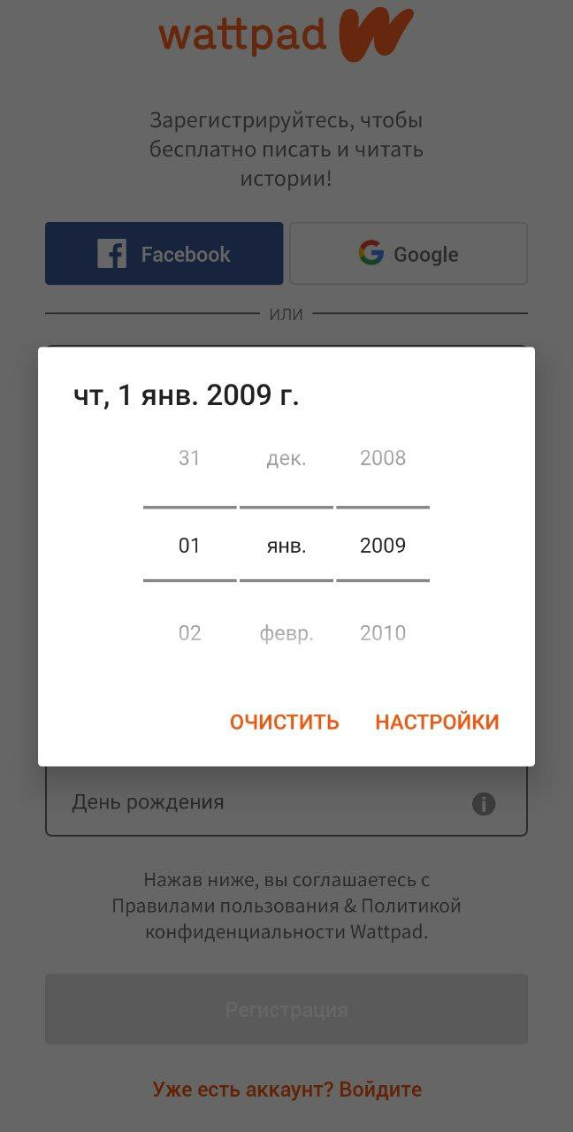

1. During reading, you can’t see your screen buttoms.

Steps:

* Download the app
* Open the app
* Click on buttom “register”
* Type in the fileds “name” , “surname” “date of birth”
* Choose genre of books
* Click on any book

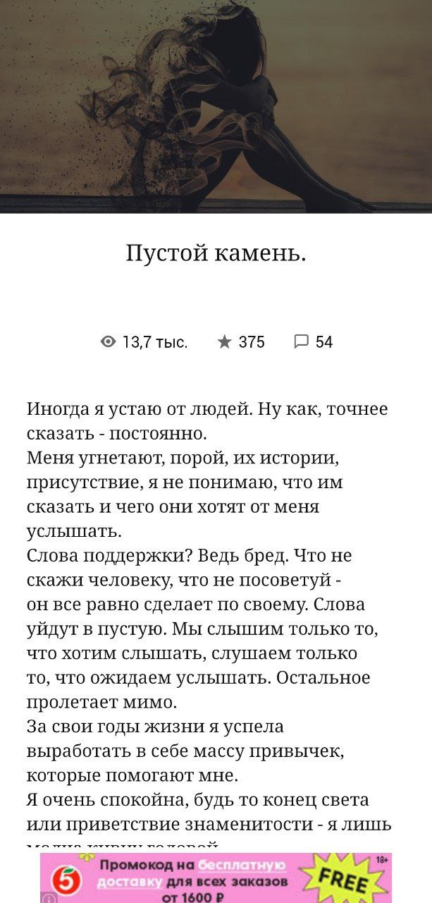

3. Sign in with the existing account is not working.

Steps:

* Download the ‘Wattpad beta’ app on your device.
* Open the app
* Register with a google account
* Log out
* Click ‘sign in’
* Input the account’s Gmail
* Input the account’s password
* Click ‘Start reading

Expected Result: You should successfully log in .

Actual Result: There is a message at the bottom of the screen saying ‘Sorry, we couldn't find an

account with that username/Gmail and password’.